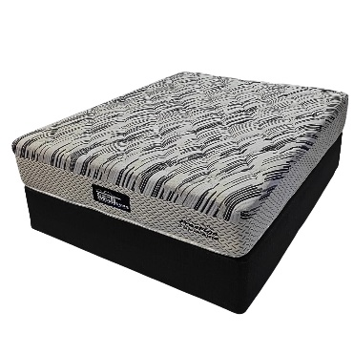
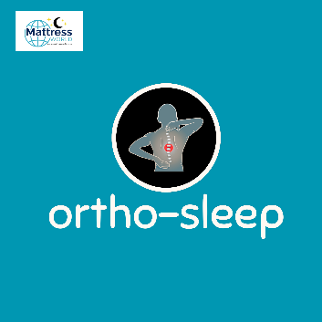

Model : Prestige-Tear Drop Bed Set
Supplier/Manufacturer : Mattress World
Range : Ortho Sleep Range – All Ortho Sleep Range Mattresses are Orthopedic Design. Made stronger to help improve posture, better quality than average mattresses and keep their shape and feel for a longer period of time. Great quality and good for back support.
Features :
- Hospitality Grade Quality
- Heavy Duty Full Body Support Spring
- Blue Gel Memory Foam Comfort Layer
- Turn Free Design
- 120kg Per Person Per Side
- 1 Year Guarantee
- 18 Year Warranty
- Medium Feel
Prices – Bed Set :
- Single Bed Set – R5199
- Three Quarter Bed Set – R6199
- Double Bed Set – R7199
- Queen Bed Set – R7199
- King Bed Set – R9199
Prices – Mattress Only :
- Single Mattress Only – R4699
- Three Quarter Mattress Only – R5699
- Double Mattress Only – R6699
- Queen Mattress Only – R6699
- King Mattress Only – R8199
Prices - Extra Length Bed Set :
- Single Extra Length Bed Set – R6239
- Three Quarter Extra Length Bed Set – R7439
- Double Extra Length Bed Set – R8639
- Queen Extra Length Bed Set – R8639
- King Extra Length Bed Set – R11039
Prices - Extra Length Mattress Only :
- Single Extra Length Mattress Only – R5639
- Three Quarter Extra Length Mattress Only – R6839
- Double Extra Length Mattress Only – R8039
- Queen Extra Length Mattress Only – R8039
- King Extra Length Mattress Only – R9839

